NICE has developed a guideline to advise your doctor, nurse or pharmacist how they can help you make decisions about your medicines
Getting the best from your medicines
Add details of sources of patient information or support within your region here
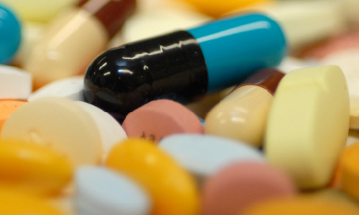
Almost everyone is prescribed a medicine at some time
Would you like to get the full benefit from your treatment?
If the answer is YES, then get involved in decisions about your medicines

If you decide not to take a medicine
tell your doctor -they can support you and explain
how this could affect you
Add your organisational
logo here
Before you decide to start or carry on using a medicine
Your doctor, nurse or pharmacist can help you:
- understand what the treatment is and
how long you need to use it
- understand the benefits of the treatment
- manage any side effects
- change your medicines if you need to
- talk about your worries about your medicines or treatment
- fit medicines into your lifestyle
They can also advise you how to get help with prescription costs, if this is a problem
Discuss your medicines
with your doctor, nurse or pharmacist


