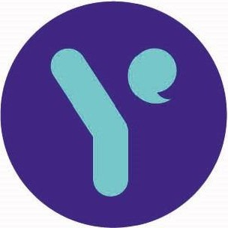

2 May 2024

To whom it may concern

Young

**Epilepsy**

**NICE final draft guidance on fenfluramine for seizures in Lennox-Gastaut syndrome**

On behalf of Young Epilepsy, I am writing in support of the Tuberous Sclerosis Association's appeal against the final NICE draft guidance on fenfluramine for treating seizures associated with Lennox-Gastaut syndrome in people aged 2 and over.

We urge NICE to reconsider its decision due to the limited seizure treatment options available to those living with Lennox-Gastaut syndrome and the need to consider the views and experiences of those directly affected.

Many epilepsy treatments do not work effectively for those with Lennox-Gastaut syndrome. Furthermore, new restrictions around the use of valproate for treating seizures may reduce medication choice further for this group. Valproate is currently recommended as a first-line treatment for seizures associated with Lennox-Gastaut syndrome.

We are conscious that the appraisal process has not been able to incorporate feedback from a dedicated patient group for those living with Lennox-Gastaut syndrome. Global support is provided through the LGS Foundation, which is based in the United States. We urge NICE to consider a further consultation period to engage UK families connected to the LGS Foundation, as well as others that can speak directly about the impact of seizures as part of Lennox-Gastaut syndrome.

**We hope that NICE will enable further consultation to take place before a final decision is reached.**

Yours sincerely

XXXXXXXXXX

Head of Voice, Policy and Influencing

St Piers Lane, Lingfield Surrey RH? 6PW

**t.**

01342 832243

**f.** 01342 834639

**e.** [info@youngepilepsy.org.uk](mailto:info@youngepilepsy.org.uk)

**w.** youngepilepsy.org.uk

**together we create possible**

Young Epilepsy is the operating name of The National Centre for Young People with Epilepsy Charitable Trust. Registered Charity number 311877 (England and Wales).