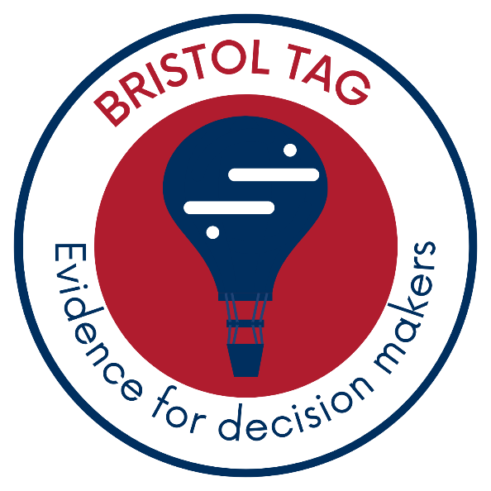

Natalizumab and Tyruko (natalizumab biosimilar) for treating highly active relapsing-remitting multiple sclerosis after at least one disease modifying therapy: a systematic review and economic model

ADDENDUM

Produced by: Bristol Technology Assessment Group

Handling of information from the company submissions

Assessment of clinical effectiveness
All information submitted by the company was reviewed by the EAG to determine whether any studies referenced in the submission fulfilled inclusion criteria for the review (section 4.1 of the EAG report). These specified that to be included studies had to be randomised controlled trials conducted in a population with RRMS. Studies were required to compare one of the eligible interventions to an alternative eligible intervention, or to placebo, so that only studies that were informative for the network were included. Studies that only compared different doses, modes of administration, or manufacturers of the same intervention were excluded, unless these were needed to create a connected network.

The EAG also reviewed the company submission to determine whether these included any data not available in published sources, including previous technology appraisals.

This approach is summarised in the methods section of the report (section 4.2.1):
“NICE requested submissions from Companies with technologies in scope for this appraisal (See Table 3). We checked the submissions for studies (and study data) which align with our inclusion criteria. Any studies identified through this process were tabulated to show where they contributed to our review or why they were excluded (Appendix 2).”
All RCT evidence included in the company submissions was also identified by the EAGs literature searches; no additional relevant information was included in the company submissions beyond what was available in published sources. This is reported in section 5 of the report:
“The submissions from the manufacturers for the two drugs of interest for this appraisal (Biogen and Sandos) did not include any relevant studies that we had not identified in our searches – studies included in these submissions, review decision, and reasons for exclusion (where appropriate) are summarised in Table 39 and Table 40 (Appendix 3).”
The company submission included some additional evidence that did not fulfil inclusion criteria for the review. Details on whether each of the studies included in the company submission were eligible for inclusion in the clinical effectiveness review, with reasons for exclusion as appropriate, are outlined in Table 39 (studies included in the Biogen submission) and Table 40 studies included in the Sandoz submission) in Appendix 2.
Studies that did not fulfil the pre-specified review inclusion criteria were not critiqued in detail. However, the EAG do draw on these in the discussion section of the report (section 8.1.1) in the context of evidence included in our review, as follows:
“All trials of natalizumab evaluated natalizumab administered intravenously - there were no studies of natalizumab administered subcutaneously. We did not identify any studies that compared subcutaneous administration of natalizumab with another intervention of interest for this appraisal. We are aware of a small number of trials that have compared different modes of administration of natalizumab, but none met inclusion criteria for our review. DELIVER compared the pharmacokinetics and pharmacodynamics of single subcutaneous or intramuscular 300 mg doses of natalizumab with IV 300 mg doses in patients with MS with a short follow-up duration of 24 weeks and REFINE compared switching to different dosing regimens in stable patients with RRMS who were treated with natalizumab. This study did not meet inclusion criteria for our review as all participants were already receiving natalizumab. These two studies found that natalizumab administered as a 300 mg SC injection every 4 weeks was comparable to 300 mg IV infusion natalizumab every 4 weeks in terms of ARR and CDP3 at week 60 as well as for pharmacokinetics, pharmacodynamics, and safety outcomes.”
“In addition to the data from RCTs in people with HARRMS, there is some evidence from non-randomised studies on the effectiveness of natalizumab in people with HARRMS; these studies were not included in our SLR and NMA as our inclusion criteria specified that only RCTs were eligible. A recent targeted literature review and meta-analysis of natalizumab for the treatment of highly active RRMS included studies in adults (≥ 18 years) with a confirmed diagnosis of RRMS who had an unchanged or increased relapse rate compared with the previous year, failed to respond to a full and adequate course of disease modifying therapy (DMT), and had experienced at least one relapse in the previous year while on therapy. They included 16 non-randomised studies that compared natalizumab to interferon beta, glatiramer acetate, teriflunomide, dimethyl fumarate and fingolimod and 11 case series of people treated with natalizumab. Data in the HARRMS population are also available for the TOP study, the largest real world study of natalizumab, that evaluated the long-term safety and efficacy of natalizumab in 6321 patients (134 UK patients) with RRMS with a follow-up pf 15 years. 151 A post-hoc subgroup analysis in a subset of patients with HARRMS, defined as those who had received prior treatment with ≥1 DMT and had experienced 1 relapse reported similar findings to the findings in the general RRMS population of a reduction of over 90% compared to the year before starting natalizumab. These findings support natalizumab improving outcomes for patients with RRMS and HARRMS, but do not provide a comparison with other interventions.”

Assessment of cost effectiveness

Assumptions in the EAG model and manufacturer submitted cost-comparisons
Both Biogen and Sandoz submitted cost-comparisons. We considered the assumptions of the manufacturer submission when developing our model. Table 1 presents a comparison of manufacturer costing assumptions with the EAG base case. Our assumptions were formed after reviewing TAs within the scope and discussions with clinical advisors, and these are detailed in the main report. Note that interventions and comparators were restricted and not aligned with the PICOS of our assessment. Treatment list prices are published list prices by the British National Formulary and not considered in the comparison.

Table 1 Comparison of costing assumptions from EAG’s base case with manufactures’ submissions
Treatments | EAG base case | Biogen | Sandoz | Rationale behind EAG base case assumptions
 | Natalizumab-IV  Natalizumab-biosimilar-IV  Natalizumab-SC | Natalizumab-IV  Natalizumab-SC | Natalizumab-biosimilar-IV
Comparators | Alemtuzumab  Cladribine tablets  Fingolimod  Ocrelizumab  Ofatumumab  Ponesimod  Interferon beta 1a 30 mcg  Interferon beta 1a 22 mcg  Interferon beta 1a 44 mcg  Peginterferon beta 1a 125 mcg  Glatiramer acetate 20 mg  Glatiramer acetate 40 mg | None | Natalizumab-IV  Natalizumab-SC  Ocrelizumab  Ofatumumab | As per scope.
Cost-effectiveness analysis | yes | no | no | -
No of doses per year | yes | yes | yes | As per clinical advisors.
Treatment administration (HRG) costing –day case | yes | no | yes | Day case is required as per clinical advisors.
Treatment administration activity-based costing:  - Treatment administration time in minutes  - Treatment preparation time in minutes  - Nurse hourly rates  - equipment costs per administration  - number of patients per nurse | no | yes | no
Reduction in administration time | no | yes | no | IV and SC patients are treated the same as per clinical advisors.
Reduction in observation:  - time  - number of patients | no | yes | no
Annual treatment Monitoring visits with health care professionals and associated costs (in patient/out patient care, tests, etc..) | yes | no | no | Required as per clinical advisors.

