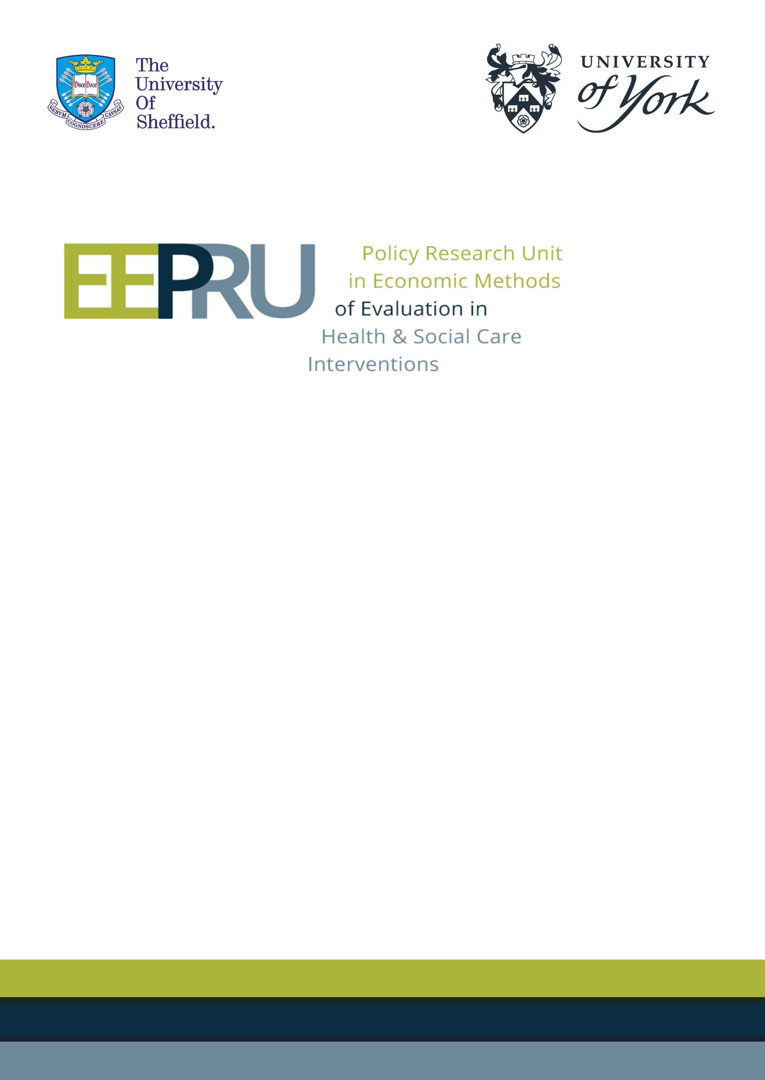

**Final report for the technology evaluation of ceftazidime with avibactam for treating severe aerobic Gram-negative bacterial infections**

**21st January 2022**



EEPRU model errors

An error in the EEPRU model relating to the long-term survival with acute kidney injury (AKI) and chronic kidney disease (CKD) impacted the long-term costs, and life year (LY) and quality-adjusted life year (QALY) gains for all comparators. Two further errors were identified by Shionogi, detailed in their consultee comments. This section outlines the impact of the errors on the model results.

Summary of results

The impact of model errors identified by Shionogi was detailed in the EEPRU’s documented responses to key consultee comments. In short, rectifying the errors had the following impact.

* No impact on expected outcomes in the base-case model.
* Negligible impact on uncertainty in patient-level incremental net health benefit (INHE) in the empiric setting.
* Decreased the patient-level benefit of CAZ-AVI in the scenario with higher costs of long-term care.

Correcting the additional error relating to the long-term survival with acute kidney injury (AKI) and chronic kidney disease (CKD) increased the patient level INHE in all scenarios. The changes in the base-case results are summarised in Table 1. In the scenario analyses in the empiric setting (ES) (Table4 in Section 3.1), the error did not impact which of the scenarios modified the deterministic base-case INHE by more than 10%. In the scenario analyses in the microbiology directed setting (MDS) (Table 6 in Section 3.2) two scenarios (where absolute risk of CKD and odds ratios of mortality associated with nephrotoxicity were informed using alternative sources) no longer modified the deterministic base-case by more than 10%; while one additional scenario (when loglogistic distribution was fitted to data predicting long term outcomes) did impact the results.

Table . Basecase patient-level INHE (probabilistic, 2,000 simulations) in the EEPRU report and post-correction. (Update of Table 36 in EEPRU report)

|  |  |  |
| --- | --- | --- |
|  | INHE (QALYs) in EEPRU report (Table 36 in EEPRU report) | INHE (QALYs) corrected (Tables 3 and 5 in Addendum 2) |
| HAP/VAP ES, nca | 0.160 (Table 36) | 0.165 (Table 3) |
| HAP/VAP ES, ca | 0.186 (Table 36) | 0.215 (Table 3) |
| HAP/VAP MDS | 0.060 (Table 38) | 0.071 (Table 5) |
| cUTI MDS | 0.049 (Table 38) | 0.069 (Table 5) |

ca, colistin/aminoglycoside therapy; cUTI, complicated urinary tract infections; ES, empiric setting; HAP/VAP, hospital-acquired pneumonia or ventilator-associated pneumonia; INHE, incremental net health effect; MDS, microbiology-directed setting; nca, non-colistin/aminoglycoside therapy; QALYs, quality-adjusted life years

When the corrected patient-level INHE was extrapoalted to the population in HVCS, the total population-level INHE increased, as shown in Table 2. The impact of the error is relatively small, with total population-level INHE changing from between 493 and 2,211 QALYs in the EEPRU report to between 531 and 2,342 post corrections, where ranges represent the mean INHE based on different assumptions about the population size (scenarios P1G1 and P2G2 in the EEPRU report). The relatively small impact of the error on the population-level results reflects the small impact of the error on the patient-level results in the ES that constitutes the largest proportion of the total population estimate. In the population-level scenario analyses, the error did not impact the scenarios that modified the deterministic base case INHE by more than 10%.

Table . Base-case population-level INHE (deterministic) in the EEPRU report and post-correction. Ranges represent different assumptions about the population size (scenarios P1G1 and P2G2 in the EEPRU report). (Update of Table 36 in EEPRU report)

|  |  |  |
| --- | --- | --- |
|  | INHE (QALYs) in EEPRU report  (Table 40 in EEPRU report) | INHE (QALYs) corrected  (Table 7 in Addendum 2) |
| HAP/VAP ES | 51 - 946 | 51 - 950 |
| cUTI MDS | 71 - 274 | 95 - 370 |
| BSI ES | 341 - 916 | 343 - 921 |
| IAI MDS | 31 - 75 | 42 - 101 |
| Total | 493 – 2,211 | 531 – 2,342 |

BSI, bloodstream infections, cUTI, complicated urinary tract infections; ES, empiric setting; HAP/VAP, hospital-acquired pneumonia or ventilator-associated pneumonia; IAI, intra-abdominal infections; INHE, incremental net health effect; MDS, microbiology-directed setting; nca, non-colistin/aminoglycoside therapy; QALYs, quality-adjusted life years

P1G1: baseline population (point estimate) based on PHE categorisation of infection sites, growth rate damped; P2G2: baseline population (point estimate) based on clinical advisors’ categorisation of infection sites, growth rate not damped.

The updated tables for all patient-level and population-level net health effects (NHE) in the high value clinical scenarios (HVCS) are presented below.

Updated figures and tables

* + 1. Patient-level outcomes: basecase results in the ES

Table : Patient-level base-case results: OXA-48 *Enterobacterales* HAP/VAP empiric setting (probabilistic, 2,000 simulations). (Update of Table 36 in EEPRU report)

|  |  |  |  |  |  |  |  |
| --- | --- | --- | --- | --- | --- | --- | --- |
|  | **Comparator treatment strategies in the empiric setting** | | | | | **Incremental results** | |
| **E1** | **E2nca** | **E2ca** | **E3nca** | **E3ca** | **E1-E2nca** | **E1-E2ca** |
| **Patients with OXA-48 *Enterobacterales*** | | | | | | | |
| ***Summary of in-hospital outcomes (proportions) across both lines of treatment available*** | | | | | | | |
| Death | 0.361 | 0.463 | 0.409 | 0.450 | 0.407 | -0.102 | -0.049 |
| Survival no AKI | 0.514 | 0.403 | 0.423 | 0.417 | 0.425 | 0.111 | 0.090 |
| Survival AKI | 0.125 | 0.135 | 0.167 | 0.133 | 0.168 | -0.009 | -0.042 |
| Survival CKD | 0.000 | 0.000 | 0.000 | 0.000 | 0.000 | 0.000 | 0.000 |
| ***Economic outcomes (all discounted)*** | | | | | | | |
| Treatment costs | £39 | £177 | £440 | £125 | £430 | -£138 | -£402 |
| AKI costs hospital | £1,735 | £2,356 | £2,318 | £2,256 | £2,305 | -£621 | -£583 |
| Other costs hospital | £17,543 | £26,651 | £16,803 | £26,289 | £16,694 | -£9,108 | £739 |
| Long-term costs | £601 | £510 | £563 | £521 | £566 | £91 | £37 |
| Total costs | £19,917 | £29,694 | £20,125 | £29,191 | £19,996 | -£9,776 | -£208 |
| Life years | 2.75 | 2.29 | 2.49 | 2.34 | 2.51 | 0.468 | 0.26 |
| QALYs | 1.93 | 1.61 | 1.75 | 1.65 | 1.76 | 0.329 | 0.182 |
| Per person NHE (QALYs) | 0.94 | 0.12 | 0.75 | 0.19 | 0.76 | 0.818 | 0.193 |
| **Patients without OXA-48 *Enterobacterales*** | | | | | | | |
| ***Summary of in-hospital outcomes (proportions) across both lines of treatment available*** | | | | | | | |
| Death | 0.357 | 0.357 | 0.409 | 0.357 | 0.409 | 0 | -0.052 |
| Survival no AKI | 0.517 | 0.517 | 0.423 | 0.517 | 0.423 | 0 | 0.094 |
| Survival AKI | 0.125 | 0.125 | 0.167 | 0.125 | 0.167 | 0 | -0.042 |
| Survival CKD | 0 | 0 | 0 | 0 | 0 | 0 | 0 |
| ***Economic outcomes (all discounted)*** | | | | | | | |
| Treatment costs | £34 | £44 | £440 | £44 | £440 | -£10 | -£406 |
| AKI costs hospital | £1,714 | £1,714 | £2,318 | £1,714 | £2,318 | £0 | -£604 |
| Other costs hospital | £17,213 | £17,213 | £16,803 | £17,213 | £16,803 | £0 | £409 |
| Long-term costs | £604 | £604 | £563 | £604 | £563 | £0 | £40 |
| Total costs | £19,564 | £19,574 | £20,125 | £19,574 | £20,125 | -£10 | -£561 |
| Life years | 2.768 | 2.768 | 2.493 | 2.768 | 2.493 | 0 | 0.275 |
| QALYs | 1.945 | 1.945 | 1.752 | 1.945 | 1.752 | 0 | 0.193 |
| Per person NHE (QALYs) | 0.967 | 0.966 | 0.746 | 0.966 | 0.746 | 0.001 | 0.221 |
| **All patients presenting in the ES** | | | | | | | |
| Total costs | £19,634 | £21,575 | £20,125 | £21,476 | £20,100 | -£1,941 | -£491 |
| QALYs | 1.943 | 1.878 | 1.752 | 1.886 | 1.754 | 0.065 | 0.191 |
| Per person NHE (QALYs) | 0.961 | 0.799 | 0.746 | 0.812 | 0.749 | 0.163 | 0.215 |

Abbreviations: AKI, acute kidney injury; CKD, chronic kidney disease; NHE, net health effect; QALYs, quality-adjusted life years

Comparators: E1 = empiric treatment with CAZ-AVI, followed by existing therapies in MDS if not susceptible; E2nca = non-colistin or aminoglycoside-based empiric treatment, followed by existing therapies MDS if needed; E2ca = colistin or aminoglycoside-based empiric treatment, followed by existing therapies MDS if needed; E3nca = non-colistin or aminoglycoside-based empiric treatment, followed by followed by CAZ-AVI in MDS if needed; E3ca = colistin or aminoglycoside-based empiric treatment, followed by CAZ-AVI MDS if needed. Net health effects derived using threshold of £20,000/QALY.

**Figure 1: Distribution of patient-level INHEs of CAZ-AVI in OXA-48 HAP/VAP empiric setting compared to (a) non-colistin/aminoglycoside-based therapy and (b) colistin/aminoglycoside-based therapy and (2,000 simulations). (Update of Figure 23 in EEPRU report)**

**(a) (b)**

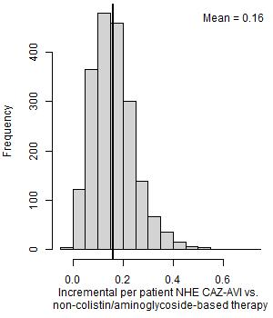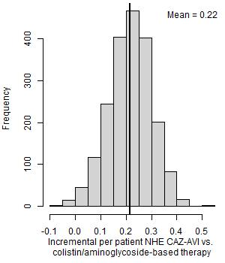

NHE, net health effects

Table : Patient-level scenario analyses: OXA-48 Enterobacterales HAP/VAP empiric setting (deterministic). (Update of Table 37 in EEPRU report)

|  |  |  |  |  |
| --- | --- | --- | --- | --- |
| **Scenario name** | **Base case value/assumption** | **Scenario value/assumption** | **Best existing treatment** | **Patient-level INHE of CAZ-AVI** |
| Base case | - | - | Non-colistin/amino-based | 0.159 |
| p_bug_survey | Probability patient has OXA-48 *Enterobacterales* is 0.20 | Probability patient has MBL *Enterobacterales* is 0.57 based on BSAC survey data | Colistin/amino based | 0.222 |
| p_bug_0 | Probability patient has OXA-48 *Enterobacterales* is 0.20 | Probability patient has OXA-48 *Enterobacterales* is 0.00 | Non-colistin/amino-based | 0.001 |
| p_bug_10 | Probability patient has OXA-48 *Enterobacterales* is 0.20 | Probability patient has OXA-48 *Enterobacterales* is 0.10 | Non-colistin/amino-based | 0.082 |
| p_bug_30 | Probability patient has OXA-48 *Enterobacterales* is 0.20 | Probability patient has OXA-48 *Enterobacterales* is 0.30 | Colistin/amino based | 0.230 |
| p_bug_40 | Probability patient has OXA-48 *Enterobacterales* is 0.20 | Probability patient has OXA-48 *Enterobacterales* is 0.40 | Colistin/amino based | 0.227 |
| p_bug_50 | Probability patient has OXA-48 *Enterobacterales* is 0.20 | Probability patient has OXA-48 *Enterobacterales* is 0.50 | Colistin/amino based | 0.225 |
| p_bug_60 | Probability patient has OXA-48 *Enterobacterales* is 0.20 | Probability patient has OXA-48 *Enterobacterales* is 0.60 | Colistin/amino based | 0.222 |
| p_bug_70 | Probability patient has OXA-48 *Enterobacterales* is 0.20 | Probability patient has OXA-48 *Enterobacterales* is 0.70 | Colistin/amino based | 0.219 |
| p_bug_80 | Probability patient has OXA-48 *Enterobacterales* is 0.20 | Probability patient has OXA-48 *Enterobacterales* is 0.80 | Colistin/amino based | 0.216 |
| p_bug_90 | Probability patient has OXA-48 *Enterobacterales* is 0.20 | Probability patient has OXA-48 *Enterobacterales* is 0.90 | Colistin/amino based | 0.213 |
| p_bug_100 | Probability patient has OXA-48 *Enterobacterales* is 0.20 | Probability patient has OXA-48 *Enterobacterales* is 1.00 | Colistin/amino based | 0.210 |
| S2 | Susceptibility based on network meta-analysis of EUCAST studies | Network meta-analysis: include all studies regardless of breakpoints, excluding specific arms due to inconsistency | Colistin/amino based | 0.217 |
| S3 | Susceptibility based on network meta-analysis of EUCAST studies | Susceptibility based on PHE isolate-level data (excludes fosfomycin) | Non-colistin/amino based | 0.180 |
| S4 | Susceptibility based on network meta-analysis of EUCAST studies | Susceptibility based on Vasquez-Ucha et al isolate-level data (excludes tigecycline) | Colistin/amino based | 0.263 |
| Weibull | Log-normal model fit to CARBAR survival data | Weibull model fit to CARBAR survival data | Non-colistin/amino-based | 0.135 |
| dr 1.5% |  |  |  |  |
| thresh15* | Cost-effectiveness threshold £20,000 | Cost-effectiveness threshold £15,000 | Non-colistin/amino-based | 0.191 |
| thresh30* | Cost-effectiveness threshold £20,000 | Cost-effectiveness threshold £30,000 | Non-colistin/amino-based | 0.128 |

Abbreviations: EUCAST, European Committee on Antimicrobial Susceptibility Testing; INHE, incremental net health effects; PHE, Public Health England

NB: Net health effects derived using threshold of £20,000/QALY.

* + 1. Patient-level outcomes: basecase results in the MDS

Table : Patient-level base-case results: OXA-48 *Enterobacterales* HAP/VAP and cUTI microbiology-directed setting (probabilistic, 2,000 simulations). (Update of Table 38 in EEPRU report)

|  |  |  |  |
| --- | --- | --- | --- |
|  | **MDS pathway with CAZ-AVI** | **MDS pathway without CAZ-AVI** | **Incremental values** |
| **HAP/VAP** | | | |
| ***Summary of in-hospital outcomes (proportions) across both lines of treatment available*** | | | |
| Death | 0.373 | 0.388 | -0.014 |
| Survival no AKI | 0.497 | 0.466 | 0.030 |
| Survival AKI | 0.130 | 0.146 | -0.016 |
| Survival CKD | 0.000 | 0.000 | 0.000 |
| ***Economic outcomes (all discounted)*** | | | |
| Treatment costs | £189 | £264 | -£74 |
| AKI costs hospital | £1,673 | £1,884 | -£211 |
| Other costs hospital | £34,723 | £34,737 | -£15 |
| Long-term costs | £591 | £580 | £10 |
| Total costs | £37,176 | £37,465 | -£289 |
| Life years | 2.691 | 2.611 | 0.08 |
| QALYs | 1.891 | 1.835 | 0.056 |
| Per person NHE | 0.032 | -0.038 | 0.071 |
| **cUTI** | | | |
| ***Summary of in-hospital outcomes (proportions) across both lines of treatment available*** | | | |
| Death | 0.125 | 0.136 | -0.011 |
| Survival no AKI | 0.646 | 0.607 | 0.039 |
| Survival AKI | 0.228 | 0.257 | -0.028 |
| Survival CKD | 0.000 | 0.000 | 0.000 |
| ***Economic outcomes (all discounted)*** | | | |
| Treatment costs | £189 | £264 | -£74 |
| AKI costs hospital | £1,673 | £1,884 | -£211 |
| Other costs hospital | £17,344 | £17,355 | -£11 |
| Long-term costs | £831 | £825 | £5 |
| Total costs | £20,037 | £20,328 | -£291 |
| Life years | 3.713 | 3.636 | 0.077 |
| QALYs | 2.609 | 2.555 | 0.054 |
| Per person NHE | 1.607 | 1.539 | 0.069 |

AKI, acute kidney injury; CKD, chronic kidney disease; cUTI, complicated urinary tract infections; HAP/VAP, hospital-acquired pneumonia or ventilator-associated pneumonia; MDS, microbiology-directed setting; NHE, net health effect; QALYs, quality-adjusted life years

NB: Net health effects derived using threshold of £20,000/QALY.

Figure : Distribution of INHEs of introducing CAZ-AVI in to the MDS compared to existing therapies: (a) OXA-48 *Enterobacterales* HAP/VAP and (b) OXA-48 *Enterobacterales* cUTI (2,000 simulations). (Update of Figure 24 in EEPRU report)

**(a) HAP/VAP (b) cUTI**

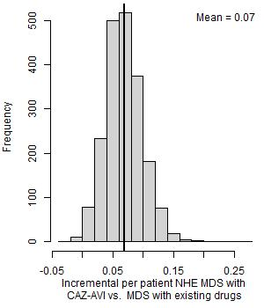

MDS, microbiology-directed setting; NHE, net health effects

Table : Per patient scenario analyses: OXA-48 HAP/VAP and cUTI MDS (deterministic). (Update of Table 39 in EEPRU report)

|  |  |  |  |  |
| --- | --- | --- | --- | --- |
| **Scenario name** | **Base case value/assumption** | **Scenario value/assumption** | **INHE per patient: HAP/VAP** | **INHE per patient: cUTI** |
| Base case | - | - | 0.080 | 0.078 |
| S2 | Susceptibility based on network meta-analysis of EUCAST studies | Network meta-analysis: include all studies regardless of breakpoints, excluding specific arms due to inconsistency | 0.066 | 0.065 |
| S4 | Susceptibility based on network meta-analysis of EUCAST studies | Susceptibility based on Vasquez-Ucha et al isolate-level data | 0.119 | 0.116 |
| p_AKI_Chien | Probability of AKI with colistin/aminoglycoside therapy based on Sisay 2021 (0.45) | Probability of AKI with colistin/aminoglycoside therapy based on Chien (0.32) | 0.066 | 0.064 |
| OR_AKI_Wagenlehner | Odds ratio comparing AKI for colistin/ aminoglycoside-based therapy to non-colistin/aminoglycoside-based therapy from all studies analysis in Chien 2020 (1.81) | Odds ratio comparing AKI for colistin/ aminoglycoside-based therapy to non-colistin/aminoglycoside-based therapy from all studies analysis in Wagenlehner 2021 (2.23) | 0.103 | 0.100 |
| OR_AKI_ChienRIFLE | Odds ratio comparing AKI for colistin/ aminoglycoside-based therapy to non-colistin/aminoglycoside-based therapy from all studies analysis in Chien 2020 (1.81) | Odds ratio comparing AKI for colistin/ aminoglycoside-based therapy to non-colistin/aminoglycoside-based therapy from RIFLE criteria studies analysis in Chien 2020 (1.61) | 0.067 | 0.065 |
| OR_AKI_death_halved | Odds ratio of mortality for AKI compared to no AKI derived from Kerr (2014) (5.11) | Odds ratio of mortality for AKI compared to no AKI halved (2.56) | 0.063 | 0.060 |
| double.ckd.risk | Risk of CKD as observed in Bucaloiu 2012 | Risk of CKD doubled to reflect potential higher propensity for CKD in HVCS | 0.070 | 0.068 |
| abs.increase | Odds ratios on mortality associated with nephrotoxicity from Bucaloiu 2012 are applied multiplicatively to underlying risk in HVCS | Absolute risk increases in Bucaloiu 2012 are assumed to apply | INHE changed by <10% | INHE changed by <10%- |
| all.aki.lt | Base case assumptions with respect to long-term effects of AKI | Applying a range of alternative assumptions to model the long-term effects of AKI | INHE changed by <10% | INHE changed by <10% |
| Weibull | Log-normal model fit to CARBAR survival data | Weibull model fit to CARBAR survival data | 0.055 | 0.054 |
| loglogistic | Log-normal model fit to CARBAR survival data | loglogistic model fit to CARBAR survival data | 0.070 | 0.068 |
| lt.care | No costs of long-term care | Costs of discharge to long-term care included | INHE changed by <10% | 0.091 |
| thresh15* | Cost-effectiveness threshold £20,000 | Cost-effectiveness threshold £15,000 |  |  |
| thresh30* | Cost-effectiveness threshold £20,000 | Cost-effectiveness threshold £30,000 |  |  |
| dr1.5* | Discount rate for costs and benefits 3.5% | Discount rate for costs and benefits 1.5% | 0.090 | 0.089 |

AKI, acute kidney injury; CKD, chronic kidney disease; EUCAST, European Committee on Antimicrobial Susceptibility Testing; HVCS, high value clinical scenario; INHE, incremental net health effects; PHE, Public Health England

NB: Net health effects derived using threshold of £20,000/QALY.

* + 1. Population-level outcomes

**Figure 3. Population INHE (QALYs) over 20 years based on two population size scenarios. P1: baseline population based on PHE categorisation of infection sites; P2: baseline population based on clinical advisors’ categorisation of infection sites; G1: damped growth rate; G2: growth rate not damped; R1: 1% resistance after 20 years; R2: 10% resistance after 20 years; R3: 30% resistance after 20 years. (Update of Figure 24 in the EEPRU report)**

1. *PHE categorisation*

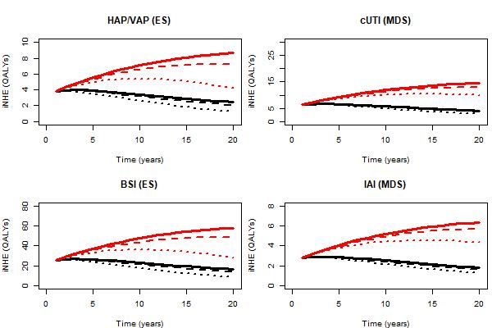

**b) Expert-guided categorisation of specimen types**

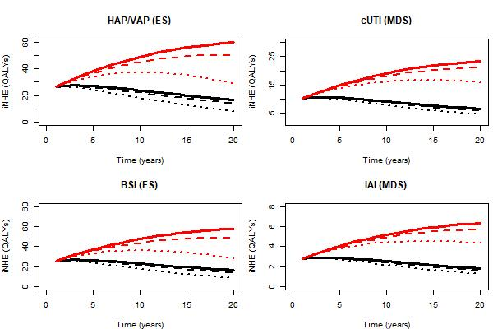

Table . Total INHE across 20 years of usage (Update of Table 40 in the EEPRU report)

|  |  |  |  |  |  |  |  |
| --- | --- | --- | --- | --- | --- | --- | --- |
| Baseline population | Population growth rate | Change in resistance | HAP/VAP | cUTI | BSI | IAI | Total |
| PHE categorisation of infection sites  (scenario P1) | Model with damped effect  (scenario G1) | 1% (R1) | 66 | 112 | 446 | 49 | 673 |
| 5% (R2) | 64 | 109 | 432 | 48 | 653 |
| 10% (R3) | 61 | 107 | 414 | 47 | 630 |
| 30% (R4) | 51 | 95 | 343 | 42 | 531 |
| Model without damped effect  (scenario G2) | 1% (R1) | 137 | 231 | 921 | 101 | 1,390 |
| 5% (R2) | 132 | 225 | 885 | 98 | 1,340 |
| 10% (R3) | 125 | 218 | 839 | 95 | 1,277 |
| 30% (R4) | 98 | 189 | 656 | 83 | 1,026 |
| Clinical advisors’ categorisation of infection sites  (scenario P2) | Model with damped effect  (scenario G1) | 1% (R1) | 460 | 179 | 446 | 49 | 1,134 |
| 5% (R2) | 446 | 175 | 432 | 48 | 1,101 |
| 10% (R3) | 427 | 171 | 414 | 47 | 1,059 |
| 30% (R4) | 354 | 153 | 343 | 42 | 892 |
| Model without damped effect  (scenario G2) | 1% (R1) | 950 | 370 | 921 | 101 | 2,342 |
| 5% (R2) | 913 | 361 | 885 | 98 | 2,257 |
| 10% (R3) | 866 | 349 | 839 | 95 | 2,149 |
| 30% (R4) | 677 | 303 | 656 | 83 | 1,719 |

BSI, bloodstream infection; cUTI, complicated urinary tract infection; HAP/VAP, hospital-acquired pneumonia or ventilator-associated pneumonia; IAI, intraabdominal infection; PHE, Public Health England

Figure . Distribution of total population INHEs of CAZ-AVI (2,000 simulations). (Update of Figure 25 in the EEPRU report)

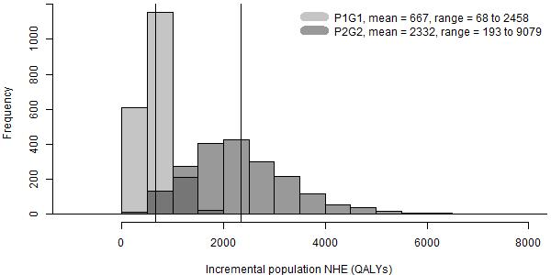

P1G1: baseline population (point estimate) based on PHE categorisation of infection sites, growth rate damped (uncertain); P2G2: baseline population (point estimate) based on clinical advisors’ categorisation of infection sites, growth rate not damped (uncertain).

Table . Total INHE across 10 years of usage. (Update of Table 68 in Appendix 20 of the EEPRU report)

|  |  |  |  |  |  |  |  |  |
| --- | --- | --- | --- | --- | --- | --- | --- | --- |
| Baseline population | Population growth rate | Change in resistance | HAP/VAP | cUTI | BSI | IAI | Total | Proportion of 20 year INHE (%) |
| PHE categorisation of infection sites  (scenario P1) | Model with damped effect  (scenario G1) | 1% (R1) | 38 | 63 | 254 | 28 | 383 | 56.9% |
| 5% (R2) | 37 | 63 | 250 | 27 | 377 | 57.7% |
| 10% (R3) | 36 | 62 | 245 | 27 | 370 | 58.7% |
| 30% (R4) | 33 | 59 | 224 | 26 | 342 | 64.4% |
| Model without damped effect  (scenario G2) | 1% (R1) | 56 | 94 | 377 | 41 | 568 | 40.9% |
| 5% (R2) | 55 | 93 | 370 | 41 | 559 | 41.7% |
| 10% (R3) | 54 | 92 | 362 | 40 | 548 | 42.9% |
| 30% (R4) | 49 | 86 | 327 | 38 | 500 | 48.7% |
| Clinical advisors’ categorisation of infection sites  (scenario P2) | Model with damped effect  (scenario G1) | 1% (R1) | 262 | 102 | 254 | 28 | 646 | 57.0% |
| 5% (R2) | 258 | 101 | 250 | 27 | 636 | 57.8% |
| 10% (R3) | 253 | 100 | 245 | 27 | 625 | 59.0% |
| 30% (R4) | 232 | 94 | 224 | 26 | 576 | 64.6% |
| Model without damped effect  (scenario G2) | 1% (R1) | 389 | 151 | 377 | 41 | 958 | 40.9% |
| 5% (R2) | 382 | 150 | 370 | 41 | 943 | 41.8% |
| 10% (R3) | 373 | 147 | 362 | 40 | 922 | 42.9% |
| 30% (R4) | 337 | 139 | 327 | 38 | 841 | 48.9% |

Table : Population-level INHE (QALYs) for patient-level scenario analyses (deterministic) – range derived from different assumptions about the population size (scenarios P1G1 and P2G2 in Figure 22). (Update of Table 41 in the EEPRU report)

|  |  |  |  |  |  |  |  |
| --- | --- | --- | --- | --- | --- | --- | --- |
| **Scenario name** | **Base case value/assumption** | **Scenario value/assumption** | **HAP/VAP (ES)** | **cUTI (MDS)** | **BSI (ES)** | **IAI (MDS)** | **Total** |
| Base case | - | - | 67-960 | 112-372 | 449-930 | 49-102 | 677-2,364 |
| p_bug_survey | Probability patient has OXA-48 *Enterobacterales* is 0.20 | Probability patient has OXA-48 *Enterobacterales* is 0.57 based on BSAC survey data | 93-1,338 | 112-372 | 627-1,297 | 49-102 | 881-3,109 |
| p_bug_10 | Probability patient has OXA-48 *Enterobacterales* in ES is 0.20 | Probability patient has OXA-48 *Enterobacterales* is 0.10 | 34-493 | 112-372 | 231-478 | 49-102 | 426-1,445 |
| p_bug_30 | Probability patient has OXA-48 *Enterobacterales* in ES is 0.20 | Probability patient has OXA-48 *Enterobacterales* is 0.30 | 97-1,386 | 112-372 | 649-1,343 | 49-102 | 907-3,203 |
| p_bug_40 | Probability patient has OXA-48 *Enterobacterales* in ES is 0.20 | Probability patient has OXA-48 *Enterobacterales* is 0.40 | 95-1,368 | 112-372 | 641-1,326 | 49-102 | 897-3,168 |
| p_bug_50 | Probability patient has OXA-48 *Enterobacterales* in ES is 0.20 | Probability patient has OXA-48 *Enterobacterales* is 0.50 | 94-1,351 | 112-372 | 633-1,309 | 49-102 | 888-3,134 |
| p_bug_60 | Probability patient has OXA-48 *Enterobacterales* in ES is 0.20 | Probability patient has OXA-48 *Enterobacterales* is 0.60 | 93-1,333 | 112-372 | 624-1,292 | 49-102 | 878-3,099 |
| p_bug_70 | Probability patient has OXA-48 *Enterobacterales* in ES is 0.20 | Probability patient has OXA-48 *Enterobacterales* is 0.70 | 92-1,316 | 112-372 | 616-1,275 | 49-102 | 869-3,065 |
| p_bug_80 | Probability patient has OXA-48 *Enterobacterales* in ES is 0.20 | Probability patient has OXA-48 *Enterobacterales* is 0.80 | 91-1,299 | 112-372 | 608-1,258 | 49-102 | 860-3,031 |
| p_bug_90 | Probability patient has OXA-48 *Enterobacterales* in ES is 0.20 | Probability patient has OXA-48 *Enterobacterales* is 0.90 | 89-1,281 | 112-372 | 600-1,241 | 49-102 | 850-2,996 |
| S2 | Susceptibility based on network meta-analysis of EUCAST studies | Susceptibility based on network meta-analysis of all studies regardless of breakpoints (excludes inconsistent arms) | 91-1,308 | 93-309 | 613-1,268 | 41-84 | 838-2,969 |
| S3 | Susceptibility based on network meta-analysis of EUCAST studies | Susceptibility based on PHE isolate-level data | 76-1,084 | 111-368 | 508-1,051 | 48-100 | 743-2,603 |
| S4 | Susceptibility based on network meta-analysis of EUCAST studies | Susceptibility based on Vasquez-Ucha et al isolate-level data | 110-1,584 | 167-554 | 742-1,535 | 73-151 | 1,092-3,824 |
| abs.increase | Odds ratios on mortality associated with nephrotoxicity from Bucaloiu 2012 are applied multiplicatively to underlying risk in HVCS | Absolute risk increases in Bucaloiu 2012 are assumed to apply | 71-1,023 | 105-347 | 479-992 | 46-95 | 701-2,457 |
| all.aki.lt | Base case assumptions with respect to long-term effects of AKI | Applying a range of alternative assumptions to model the long-term effects of AKI | 72-1,027 | 104-347 | 481-995 | 46-95 | 703-2,464 |
| Weibull | Log-normal model fit to CARBAR survival data | Weibull model fit to CARBAR survival data | 57-812 | 77-257 | 380-787 | 34-70 | 548-1,926 |
| OR_AKI_death_halved | Odds ratio of mortality for AKI compared to no AKI derived from Kerr (2014) (5.11) | Odds ratio of mortality for AKI compared to no AKI halved (2.56) | 64-923 | 87-288 | 432-894 | 38-79 | 621-2,184 |

AKI, acute kidney injury; BSI, bloodstream infection; cUTI, complicated urinary tract infection; ES, empiric setting; EUCAST, European Committee on Antimicrobial Susceptibility Testing; HAP/VAP, hospital-acquired pneumonia or ventilator-associated pneumonia; HVCS, high value clinical scenario; IAI, intraabdominal infection; MDS, microbiology-directed setting; PHE, Public Health Engl

Table error

Table 35 in the EEPRU report relating to the total number of patients treated with CAZ-AVI over 20 years reported incorrect numbers. The error only affected the table; all subsequent analyses included the correct numbers. The corrected table is provided below in Table 10.

Table 10. Total number of patients initiating CAZ-AVI over 20 years. (Update of Table 35 in the EEPRU report)

|  |  |  |  |  |
| --- | --- | --- | --- | --- |
|  | HAP/VAP | cUTI | BSI | IAI |
| Scenario P1G1 | 576 | 1,974 | 3,866 | 864 |
| Scenario P1G2 | 1,279 | 4,384 | 8,586 | 1,918 |
| Scenario P2G1 | 3,990 | 3,167 | 3,866 | 864 |
| Scenario P2G2 | 8,860 | 7,033 | 8,586 | 1,918 |

Abbreviations: BSIs, bloodstream infections; cUTIs, complicated urinary tract infections; HAP/VAP, hospital-acquired pneumonia or ventilator associated pneumonia; IAIs intraabdominal infections; MDS, microbiology-directed setting

P1G1: baseline population based on PHE categorisation of infection sites, damped growth rate; P1G2: baseline population based on PHE categorisation of infection sites, growth rate not damped; P2G1: Baseline population based on clinical advisors’ categorisation of infection sites, damped growth rate; P2G2: Baseline population based on clinical advisors’ categorisation of infection sites, growth rate not damped.