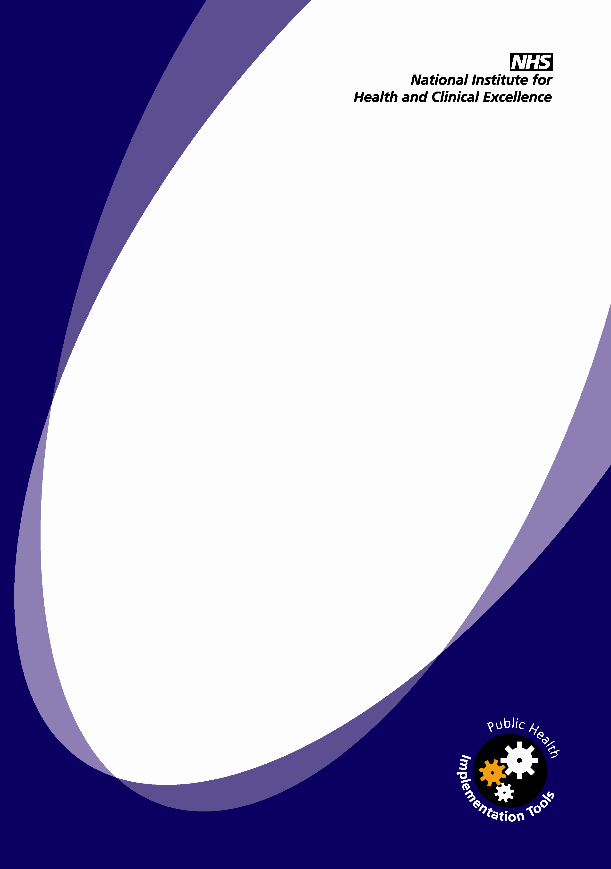
Weight management before, during and after pregnancy

Questionnaire for women

Implementing NICE guidance

2010

NICE public health guidance 27

This questionnaire accompanies the public health guidance: ‘Dietary interventions and physical activity interventions for weight management before, during and after pregnancy’ (available online at www.nice.org.uk/guidance/PH27). It has been developed to help maternity services collect data from women about the information, advice and support they have received. It can be used as part of a wider review of care provided to women during and after pregnancy. It will provide valuable information on the service offered and how it compares against the national recommendations made by the National Institute for Health and Clinical Excellence (NICE).
The questionnaire should be offered to women whose body mass index (BMI) was 30 or more before their pregnancy and/or whose BMI continues to be high after they have given birth.
In addition, NICE has produced an audit support tool and a self-assessment tool. Both can be used with this questionnaire to find out about any interventions the women were offered to help them manage their weight during pregnancy and after childbirth.
Additional questions can be added as necessary. A section has been included at the end so that women can add any further comments they may have about their experience.
This questionnaire is designed to find out about the information, advice and support you received when you attended the clinic or hospital before, during and after your pregnancy. The aim is to help us improve the care we provide and ensure we meet the national recommendations on weight management before, during and after pregnancy.
If you would like to see the recommendations, which have been published by the National Institute for Health and Clinical Excellence (NICE), please ask <local contact> for a copy or visit NICE’s website at www.nice.org.uk/guidance/PH27.

Information, advice and support |  | Yes | No |  | Not applicableOr can’t remember
Before your pregnancy
1 | When you were thinking about trying for a baby, did you receive advice from a health professional (for example, your GP) about the risks of being overweight during pregnancy – for you and your unborn baby?
2 | Were you offered the opportunity to join a weight-loss programme?
While you were pregnant
3 | Did the GP or midwife measure your weight and height at your first antenatal appointment?
 | If yes, did they explain to you why this information was needed?
4 | Did the GP or midwife talk to you about:  - your eating habits?
 | - the fact that it is a myth that you need to ‘eat for two’ while pregnant?
 | - how physically active you are?
5 | Were you offered a referral to a dietitian (someone who is an expert in food and nutrition)?
 | If not, do you think that this would have been useful?
6 | Were you given advice about how much exercise you can do during pregnancy? Did this take into account whether or not you have exercised routinely before?
After your baby was born
7 | Were you offered help to lose weight?
8 | If you were breastfeeding, were you reassured that it is fine to lose weight and take exercise – and that this would not adversely affect the quantity or quality of your milk?
General advice
9 | Do you think you were given helpful advice about:
 | - how to lose weight before pregnancy?
 | - healthy eating during pregnancy?
 | - how much exercise you should take during pregnancy?
 | - how to lose weight after pregnancy?
- healthy eating after pregnancy ?
- healthy eating and what that means for women who are breastfeeding?
 | - how much exercise you should take after pregnancy?
Do you have any further comments about your experience?
Thank you for completing this questionnaire.
Please return it to <local contact>.

